**Secretary Problem**

The secretary problem is a concept of making a decision in a selection process and optimizing our best option. The problem explores the situation where an interviewer chooses an applicant from a group of N applicants for the secretary position. Among all the candidates the interviewer is interested in finding the best candidate, *i*. The candidates can be ranked, but once a candidate is rejected they won’t be able to come back in the ranking again, so no candidate can be interviewed twice. The interviewer has the option to either accept or reject a candidate, *i*, given that each of them are treated independently. If the candidate *i* is accepted for the position then the interviewer won’t be able to view the candidate *N – i*, on the other hand, if the candidate is rejected the interviewer will be able to move to the candidate *i + 1.*

**Solution**

The underlying strategy used for the secretary problem is a stopping time with respect to a sequence of random variables, in our case i1,i2,i3,..., is a random variable, τ. For each t the occurrence or non-occurrence of the event τ = t depends on the value of i1,i2,i3,... where τ is almost finite.

The secretary problem might have many approaches and solutions, but one of the optimal solutions are as following;

The interviewer will reject the first *r* candidates where *r < N* and accepts the very next applicant who is better than all the *r* candidates who are already interviewed.

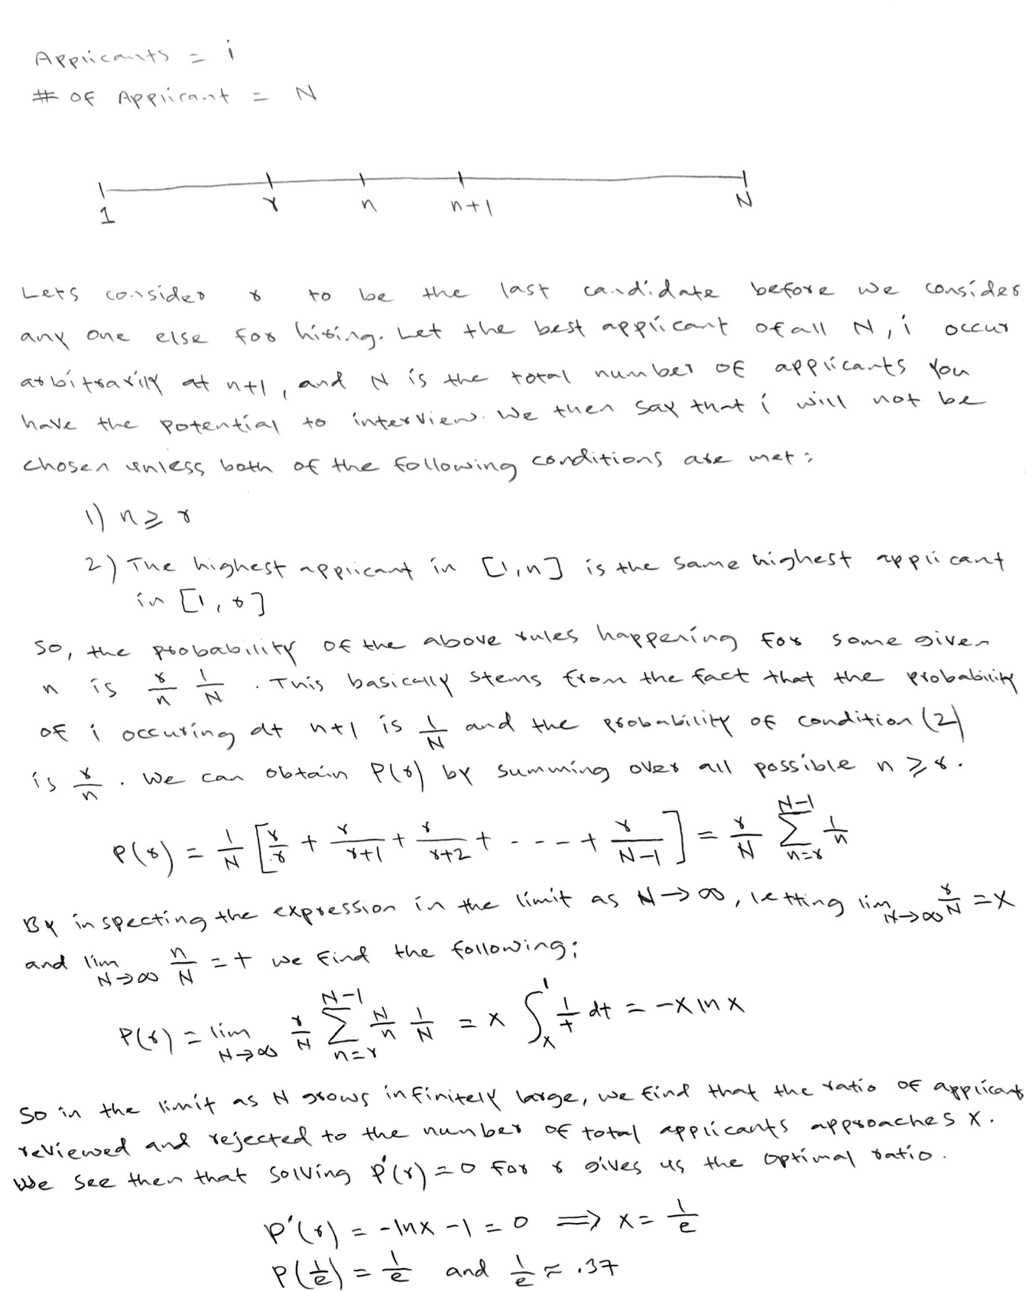

Given the above result the ratio of r to N is optimal at 1/e. So, for N > 1 the r optimal is close to N/e or it can be calculated through P(r) as well.